20230309 計算機概論 Assignment 04

**題目：**

請利用class幫忙設計一支簡易的學生系統

**題目要求**:

Class **Student**中需包含有以下元件(程式中必須使用此class 否則0分)

|  |  |  |  |
| --- | --- | --- | --- |
| 名稱 | 權限 | 型態 | 說明 |
| name | private | String | 學生名稱 |
| id | public | int | 學生id |
| dept | private | String | 學生科系 |
| getName | public | String function() | 回傳學生名稱 |

Class **Department**中需包含有以下元件(程式中必須使用此class 否則0分)

|  |  |  |  |
| --- | --- | --- | --- |
| 名稱 | 權限 | 型態 | 說明 |
| students | private | **Student**陣列 List<Student> | 科系中存在的學生 |
| name | private | String | 科系名稱 |
| addStudent() | public | void function (Student student) | 將student加入students的list中 |
| getStudents () | public | **Student**陣列 List<Student> | 回傳科系中的學生list |
| getTotalStudentsInDep | public | int function() | 回傳科系中的學生人數 |
| showDepStudents | public | Void function() | 印出該學系中的所有學生名稱 |

Class **Institute**中需包含有以下元件(程式中必須使用此class 否則0分)

|  |  |  |  |
| --- | --- | --- | --- |
| 名稱 | 權限 | 型態 | 說明 |
| departments | private | **Department**陣列 List<Department> | 學院中存在的學系 |
| name | private | String | 學院名稱 |
| getTotalStudentsInInstitute | public | int function() | 回傳學院中的學生人數 |

程式一開始於main中新增以下物件並於螢幕輸出"1.add student 2.show the number of students in a department 3.show all the students in a department 4.show the number of students in an institute 5.exit:"

**需新增的物件如下：Department CSIE, Department EE, Department MATH, Institute EECS, Institute SCI**

之後依據使用者的輸入執行不同動作：

若使用者輸入”1”：

於螢幕印出 **"Please input the student info name/id/department:"**，並讓使用者依序輸入 學生名稱 學生id 學生科系 後

新增相應**Student 物件** 並加入至**Department物件**中的students中，並再次循環功能選擇

若使用者輸入”2”：

於螢幕印出 "Please input the department:" **輸入欲查看人數的科系後並呼叫getTotalStudentsInDep** function，並再次循環功能選擇

若使用者輸入”3”：

於螢幕印出 "Please input the department:" **輸入欲查看的科系後並呼叫showDepStudents** function，印出該學系內所有學生，格式為一行一個學生，並再次循環功能選擇

若使用者輸入”4”：

於螢幕印出 "Please input the institute:" **輸入欲查看的學院後並呼叫getTotalStudentsInInstitute** function，並再次循環功能選擇

若使用者輸入”5”：

結束程式

**注意：**

1. 功能選擇不會出現除1~5外的其他狀況，無須判斷此例外
2. 輸入之科系以及學院皆為**英文大寫：CSIE, EE, MATH, EECS（電資學院）, SCI（理學院）**
3. 功能1 add student 中測資不會有同一時間存在重複學生id以及不存在科系的狀況，無須判斷此例外
4. 功能2 ~4中測資不會有不存在的科系或學院的情況，無須判斷此例外
5. 所有print方法皆須換行(例如，利用System.out.println())
6. 測資中students和departments陣列內容長度最多不超過10

詳情見下方範例

The actual input and output for running your program is something that looks like the following：

**例一：**

# input自此始，但不包括此行

1

Amy 1 CSIE

2

MATH

4

SCI

4

EECS

5

# input至此止，但不包括此comment

# output自此始，但不包括此行

1.add student 2.show the number of students in a department 3.show all the students in a department 4.show the number of students in a institute 5.exit

Please input the student info name/id/department:

1.add student 2.show the number of students in a department 3.show all the students in a department 4.show the number of students in a institute 5.exit

Please input the department:

0

1.add student 2.show the number of students in a department 3.show all the students in a department 4.show the number of students in a institute 5.exit

Please input the institute:

0

1.add student 2.show the number of students in a department 3.show all the students in a department 4.show the number of students in a institute 5.exit

Please input the institute:

1

1.add student 2.show the number of students in a department 3.show all the students in a department 4.show the number of students in a institute 5.exit

# output至此止，但不包括此comment

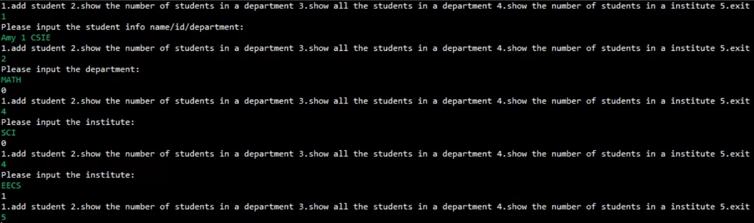

**例二：**

# input自此始，但不包括此行

1

Hank 1 MATH

1

David 1 EE

1

Ted 1 CSIE

4

EECS

5

# input至此止，但不包括此comment

# output自此始，但不包括此行

1.add student 2.show the number of students in a department 3.show all the students in a department 4.show the number of students in a institute 5.exit

Please input the student info name/id/department:

1.add student 2.show the number of students in a department 3.show all the students in a department 4.show the number of students in a institute 5.exit

Please input the student info name/id/department:

1.add student 2.show the number of students in a department 3.show all the students in a department 4.show the number of students in a institute 5.exit

Please input the student info name/id/department:

1.add student 2.show the number of students in a department 3.show all the students in a department 4.show the number of students in a institute 5.exit

Please input the institute:

2

1.add student 2.show the number of students in a department 3.show all the students in a department 4.show the number of students in a institute 5.exit

# output至此止，但不包括此comment

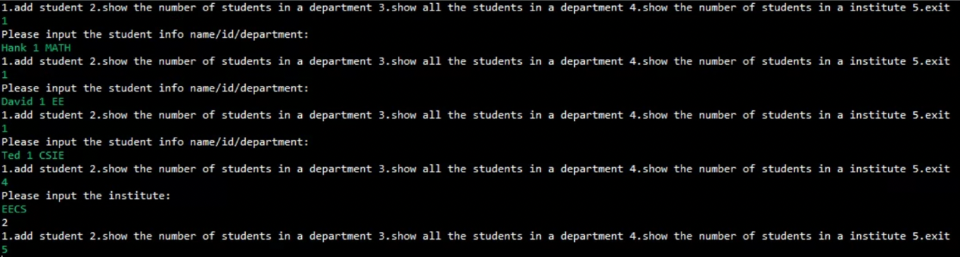

補充範例（此範例為計算機實習之題目）：

此為說明功能3的輸出格式

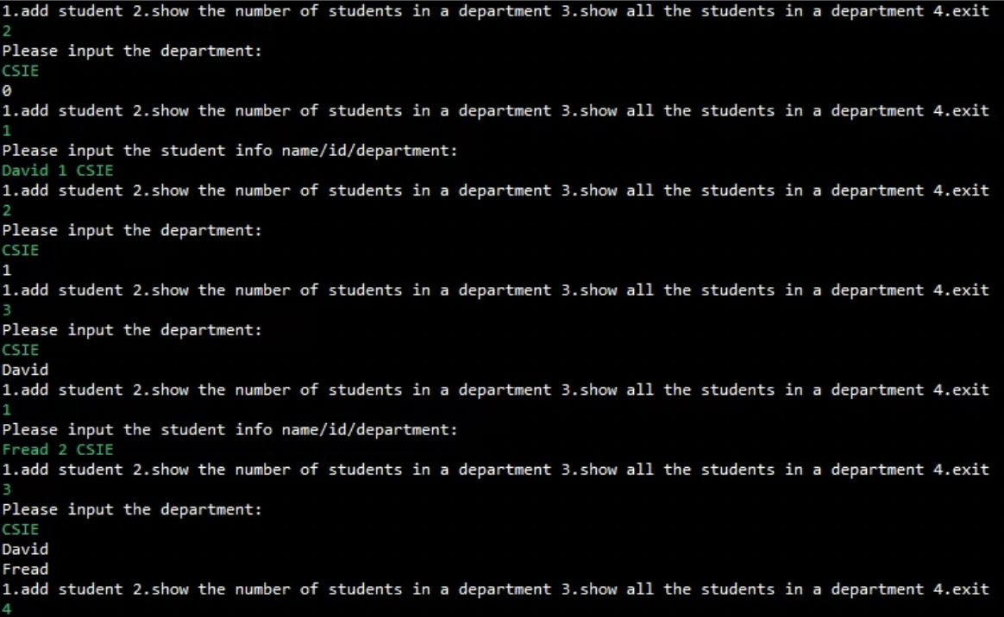

**評分標準：**

For each input (test data) file, your program must produce an output file with a content that is EXACTLY THE SAME AS the expected output. This is the only way your program can "pass" any particular test.

In general, we will use 5 test data to test your project. The total score of this project is 100 points, and each test data accounts for 20%.

**繳交格式：**

繳交方式、內容錯誤的斟酌扣分，完整作業格式詳見ee-class教材區「111-2 JAVA作業繳交及評分標準.pptx 」。若對作業有疑問，請上Discord留言或詢問助教，如有作業勘誤會於ee-class公告區或DC公告版公告，請自行留意。